Project Planning Phase
Project Planning Template (Product Backlog, Sprint Planning, Stories, Story points)

Date | 31 October 2022
Team ID | PNT2022TMID35819
Project Name | Project - Emerging Methods for Early Detection of Forest Fires
Maximum Marks | 8 Marks

Product Backlog, Sprint Schedule, and Estimation (4 Marks)
Use the below template to create product backlog and sprint schedule
Sprint | Functional  Requirement (Epic) | User Story  Number | User Story / Task | Story Points | Priority | Team  Members
Sprint-1 | Registration | USN-1 | As a user, I can register for the application by entering my email, and password, and confirming my password. | 10 | High | Narendiran B S
Sprint-1 | E-mail confirmation | USN-2 | As a user, I will receive a confirmation email once I have registered for the application | 10 | Medium | Gokulasankar M
Sprint-2 | Login | USN-3 | As a user, I can log into the application by entering my email & password | 5 | High | Narendiran B S  Jaisakthi G
Sprint-2 | Upload Images | USN-4 | As a user,I should be able to upload the image of ECG. | 10 | High | Jaisakthi G
Sprint-2 | Dashboard | USN-5 | As a user, based on my requirement I can navigate through the dashboard. | 5 | Medium | Gokulasankar M  Thamaraikannan M

Sprint-3 | Train the model | Task 1 | As a developer, the dataset will be uploaded and trained by developed algorithm. | 20 | High | Narendiran B S  Thamaraikannan M
Sprint-4 | Testing & Evaluation | Task 2 | As a developer, we tested the trained model using the provided dataset and model will be evaluated for accurate results. | 10 | High | Gokulasankar M  Jaisakthi G
Sprint-4 | Display predicted result | USN-6 | As a user, I can view the predicted result in the dashboard. | 10 | High | Thamaraikannan M

Project Tracker, Velocity & Burndown Chart: (4 Marks)
Sprint | Total Story Points | Duration | Sprint Start Date | Sprint End Date (Planned) | Story Points  Completed (as on  Planned End Date) | Sprint Release Date (Actual)
Sprint-1 | 20 | 6 Days | 24 Oct 2022 | 29 Oct 2022 | 20 | 10 Nov 2022
Sprint-2 | 20 | 6 Days | 31 Oct 2022 | 05 Nov 2022 | 20 | 17 Nov 2022
Sprint-3 | 20 | 6 Days | 07 Nov 2022 | 12 Nov 2022 | 20 | 24 Nov 2022
Sprint-4 | 20 | 6 Days | 14 Nov 2022 | 19 Nov 2022 | 20 | 30 Nov 2022

Velocity:
Imagine we have a 10-day sprint duration, and the velocity of the team is 20 (points per sprint). Let’s calculate the team’s average velocity (AV) per iteration unit (story points per day)
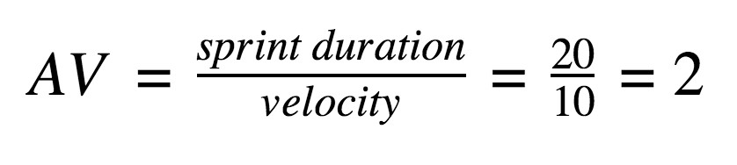
AV=20/6=3.33points per day
Burndown Chart:
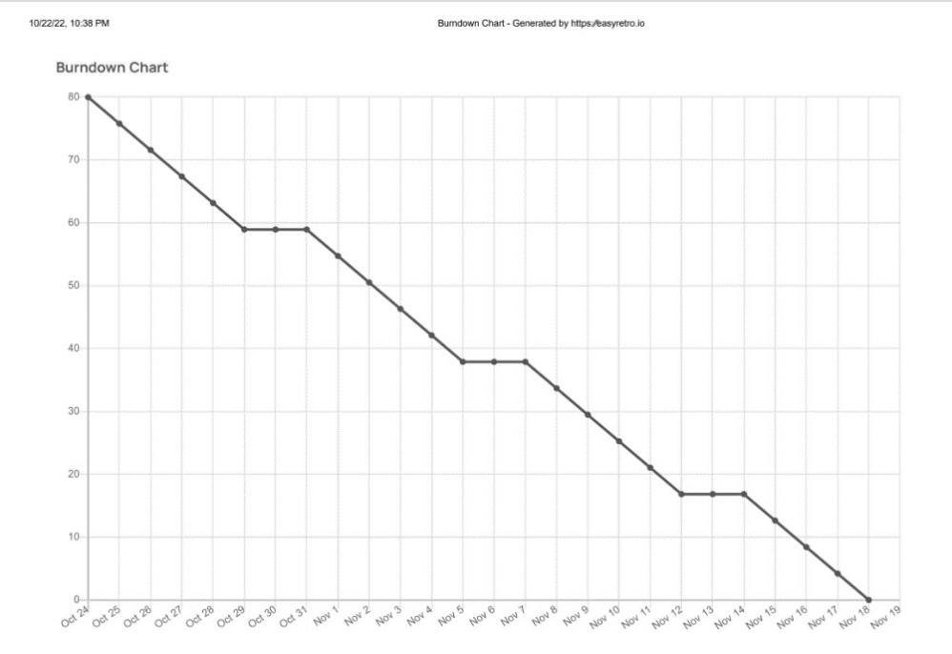
A burn down chart is a graphical representation of work left to do versus time. It is often used in agile software development methodologies such as Scrum. However, burn down charts can be applied to any project containing measurable progress over time. https://www.visual-paradigm.com/scrum/scrum-burndown-chart/
https://www.atlassian.com/agile/tutorials/burndow
n
-
chart
s

Reference:

t
https://www.atlassian.com/agile/projec
-
managemen
t

https://www.atlassian.com/agile/tutorials/ho
w
-
t
o
-
d
o
-
m
scru
-
wit
h
-
jir
a
-
softwar
e

https://www.atlassian.com/agile/tutorials/epic
s

https://www.atlassian.com/agile/tutorials/sprint
s

https://www.atlassian.com/agile/projec
t
-
management/estimatio
n

https://www.atlassian.com/agile/tutorials/burndow
n
-
chart
s

